LECTURE 2:
LAYERED TASKS : OSI MODEL
We use the concept of layers in our daily life. As an example, let us consider two friends who
communicate through postal mail. The process of sending a letter to a friend would be complex
if there were no services available from the post office. Figure 1.3 below shows tasks involved in
sending a letter:

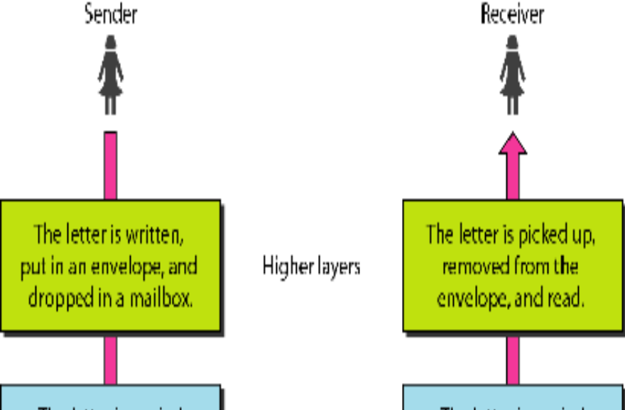
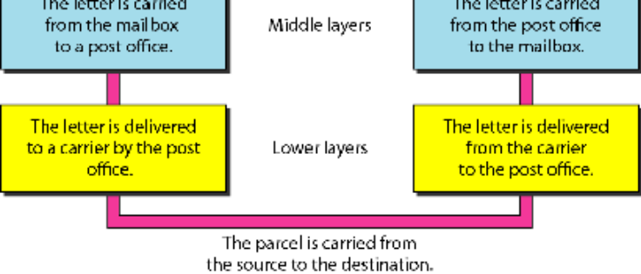
Thus from above figure it is clearly understood that layer architecture simplifies the network
Design. It is easy to debug network applications in a layered architecture network. There are two
Layered Models namely OSI Model and TCP/IP Model.

OSI MODEL: OPEN SYSTEM FOR INTERCONNECTION
International Standard Organization (ISO) established a committee in 1977 to develop
Architecture for computer communication. Open Systems Interconnection (OSI) reference model
is the result of this effort.
In 1984, the Open Systems Interconnection (OSI) reference model was approved as an
International standard for communications architecture. Term “open” denotes the ability to connect any two systems which conform to the reference model and associated standards. The
purpose of OSI Model is to facilitate communication between different systems without
requiring changes to the logic of the underlying hardware and software. The OSI model is now
considered the primary Architectural model for inter- computer communications. The OSI model
describes how information or data makes its way from application programmes (such as
spreadsheets) through a network medium (such as wire) to another application programme
located on another network. The OSI reference model divides the problem of moving
information between computers over a network medium into SEVEN smaller and more
manageable problems. This separation into smaller more manageable functions is known as
layering. Figure below shows interaction between layers in the OSI model:

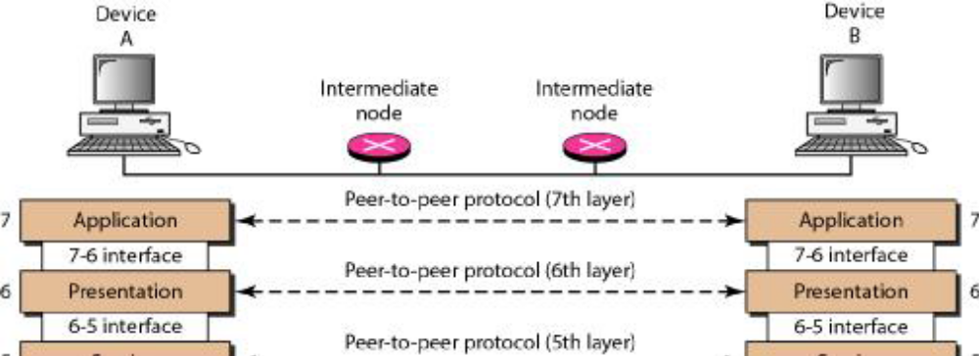
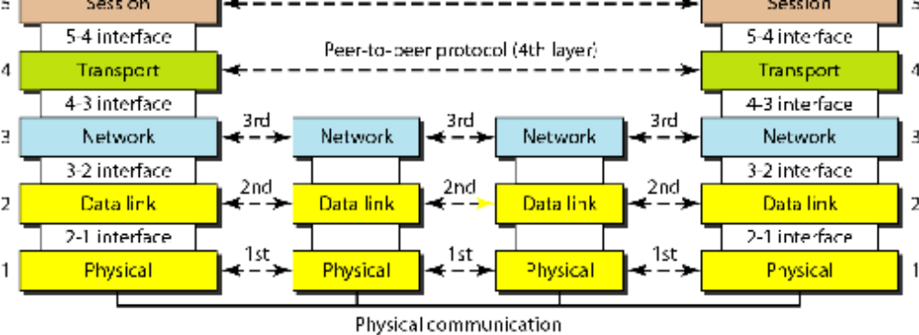

The process of breaking up the functions or tasks of networking into layers reduces complexity.
Each layer provides a service to the layer above it in the protocol specification. Each layer
communicates with the same layer’s software or hardware on other computers. The lower 4
layers (transport, network, data link and physical —Layers 4, 3, 2, and 1) are concerned with the
flow of data from end to end through the network. The upper three layers of the OSI model
(application, presentation and session—Layers 7, 6 and 5) are orientated more toward services to
the applications. Data is encapsulated with the necessary protocol information as it moves down
the layers before network transit. A message begins at the top application layer and moves down
the OSI layers to the bottom physical layer. As the message descends, each successive OSI
model layer adds a header to it. A header is layer-specific information that basically explains
what functions the layer carried out. Conversely, at the receiving end, headers are striped from
the message as it travels up the corresponding layers as shown in Fig.1.5.
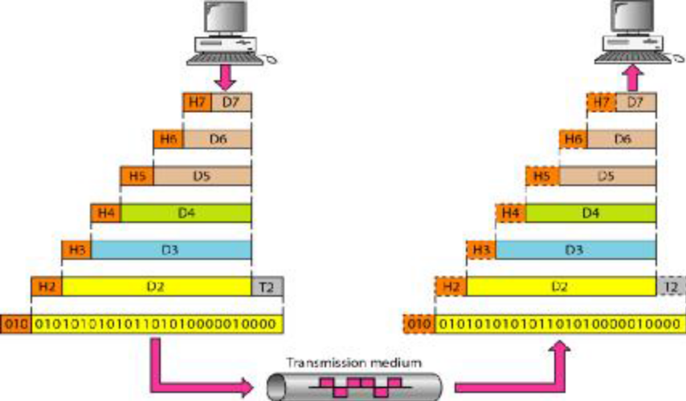
Fig 1.5 Working Principle
A) PHYSICAL LAYER
· Provides physical interface for transmission of information.
· Defines rules by which bits are passed from one system to another on a physical
communication medium.
· Covers all - mechanical, electrical, functional and procedural - aspects for physical
communication.
· Such characteristics as voltage levels, timing of voltage changes, physical data rates,
maximum transmission distances, physical connectors, and other similar attributes are
defined by physical layer specifications.
· Concerned with line configuration, physical topology and transmission mode.
B) DATA LINK LAYER
· Data link layer attempts to provide reliable communication over the physical layer
interface.
· Breaks the outgoing data into frames and reassemble the received frames.
· Create and detect frame boundaries.
· Handle errors by implementing an acknowledgement and retransmission scheme.
· Implement flow control.
· Responsible for Error Control.
· Supports points-to-point as well as broadcast communication.
· Supports simplex, half-duplex or full-duplex communication.
C) NETWORK LAYER
· Implements routing of frames (packets) through the network.
· Defines the most optimum path the packet should take from the source to the
destination.
· Defines logical addressing so that any endpoint can be identified
· Handles congestion in the network.
· The network layer also defines how to fragment a packet into smaller packets to
accommodate different media.
D) TRANSPORT LAYER
· Purpose of this layer is to provide a reliable mechanism for the exchange of data
between two processes in different computers.
· Ensures that the data units are delivered error free.
· Ensures that data units are delivered in sequence.
· Ensures that there is no loss or duplication of data units.
· Provides connectionless or connection oriented service.
· Provides for the connection management.
· Multiplex multiple a connection over a single channel.
E) SESSION LAYER
· Session layer provides mechanism for controlling the dialogue between the two end
systems.
· It defines how to start, control and end conversations (called sessions) between
applications.
· This layer requests for a logical connection to be established on an end-user’s request.
· Any necessary log-on or password validation is also handled by this layer.
· Session layer is also responsible for terminating the connection.
· This layer provides services like dialogue discipline which can be full duplex or half
duplex.
· Session layer can also provide check-pointing mechanism such that if a failure of
some sort occurs between checkpoints, all data can be retransmitted from the last
checkpoint.
F) PRESENTATION LAYER
· Presentation layer defines the format in which the data is to be exchanged between
the two communicating entities.
· Also handles data compression and data encryption (cryptography).
G) APPLICATION LAYER
· Application layer interacts with application programs and is the highest level of OSI
model.
· Application layer contains management functions to support distributed applications.
· Examples of application layer are applications such as file transfer, electronic mail,
remote login etc.
Fig. 1.6 below shows summary of all layers of OSI Model:

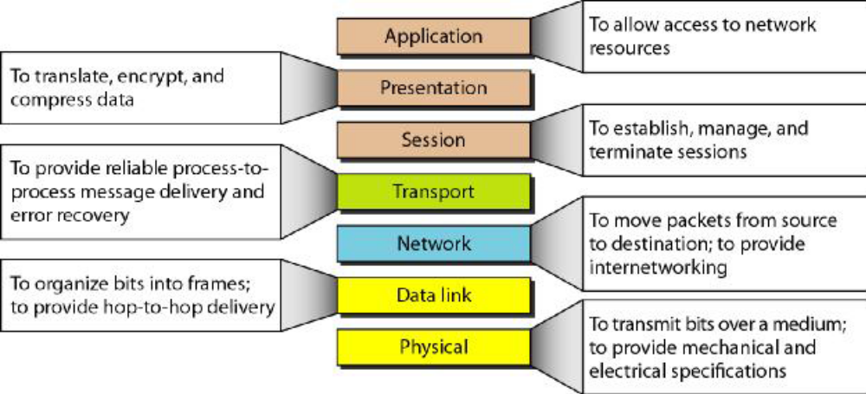
Fig 1.6 Summary of OSI Model

1.5 TCP/IP MODEL: (TRANSMISSION CONTROL PROTOCOL/ INTERNET
PROTOCOL)
The layers in the TCP/IP protocol suite do not exactly match those in the OSI model. The
original TCP/IP protocol suite was defined as having four layers: host-to-network, internet,
transport, and application. However, when TCP/IP is compared to OSI, we can say that the
TCP/IP protocol suite is made of five layers: physical, data link, network, transport, and
application. Fig. 1.7 below shows TCP/IP layers in comparison to OSI Model:

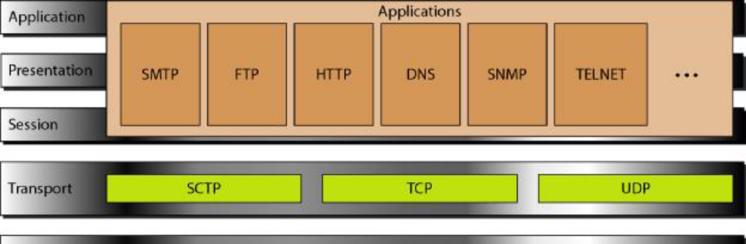
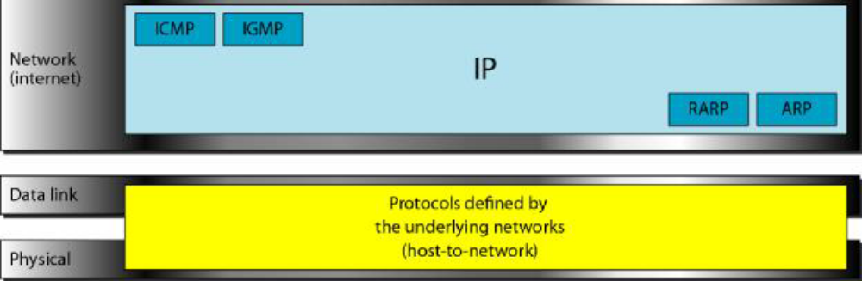
Fig 1.7 TCP/IP Model Vs OSI Model
A) APPLICATION LAYER
Application layer protocols define the rules when implementing specific network applications. It
relies on the underlying layers to provide accurate and efficient data delivery.
Typical protocols are:
· FTP – File Transfer Protocol: For file transfer
· Telnet – Remote terminal protocol: For remote login on any other computer on the
network
· SMTP – Simple Mail Transfer Protocol: For mail transfer
· HTTP – Hypertext Transfer Protocol: For Web browsing
B) TRANSPORT LAYER
Transport Layer protocols define the rules of dividing a chunk of data into segments and then
reassemble segments into the original chunk. Typical protocols are:TCP – Transmission Control
Protocol: Provide functions such as reordering and data resend.
· UDP – User Datagram Service: Use when the message to be sent fit exactly into a
datagram and Use also when a more simplified data format is required.
· SCTP - Stream Control Transmission Protocol: The Stream Control Transmission
Protocol (SCTP) provides support for newer applications such as voice over the Internet

C) NETWORK LAYER
Network layer protocols define the rules of how to find the routes for a packet to the destination
It only gives best effort delivery. Packets can be delayed, corrupted, lost, duplicated, out-oforder.
· IP – Internet Protocol: Provide packet delivery
· ARP – Address Resolution Protocol: Define the procedures of network address / MAC
address translation i.e The Address Resolution Protocol (ARP) is used to associate a
logical address with a physical address. ARP is used to find the physical address of the
node when its Internet address is known.
· RARP – Reverse Address Resolution Protocol: The Reverse Address Resolution Protocol
(RARP) allows a host to discover its Internet address when it knows only its physical
address.
· ICMP – Internet Control Message Protocol: The Internet Control Message Protocol
(ICMP) is a mechanism used by hosts and gateways to send notification of datagram
problems back to the sender.
· IGMP – Internet Group Message Protocol: The Internet Group Message Protocol
(IGMP) is used to facilitate the simultaneous transmission of a message to a group of
recipients.
D) PHYSICAL AND DATA LINK LAYER
At the physical and data link layers, TCP-IP does not define any specific protocol. Rather, it
supports all the standard protocols.

1.6 ADDRESSING
There are four levels of addresses are used in an internet employing the TCP/IP protocols:
physical, logical, port, and specific. Figure 1.8 below shows relationship of layers and addresses
in TCP/IP:

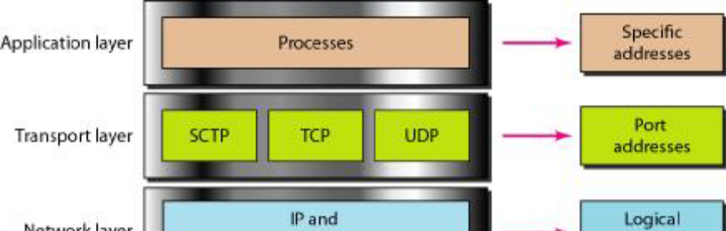

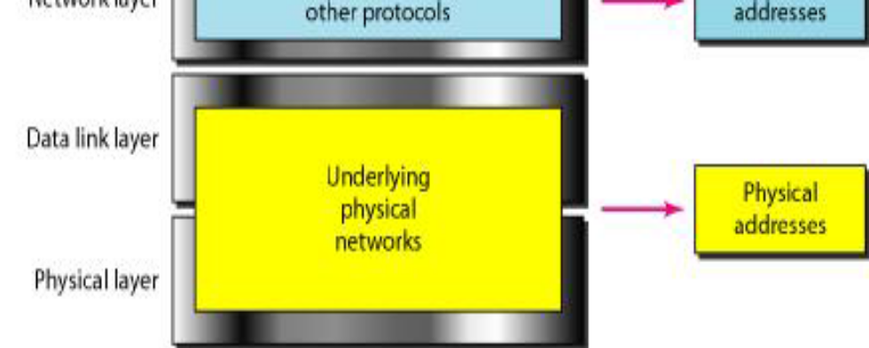

Fig 1.8 TCP/IP Addressing

1.8 TRANSMISSION MEDIA
A transmission medium can be broadly defined as anything that can carry information from a
source to a destination. For example, the transmission medium for two people having a dinner
conversation is the air. The air can also be used to convey the message in a smoke signal or
semaphore. For a written message, the transmission medium might be a mail carrier, a truck, or
an airplane. In data communications the definition of the information and the transmission
medium is more specific. The transmission medium is usually free space, metallic cable, or fiber optic cable. The information is usually a signal that is the result of a conversion of data from
another form. It can be classified as shown in Fig 1.18: Guided and Unguided as shown below

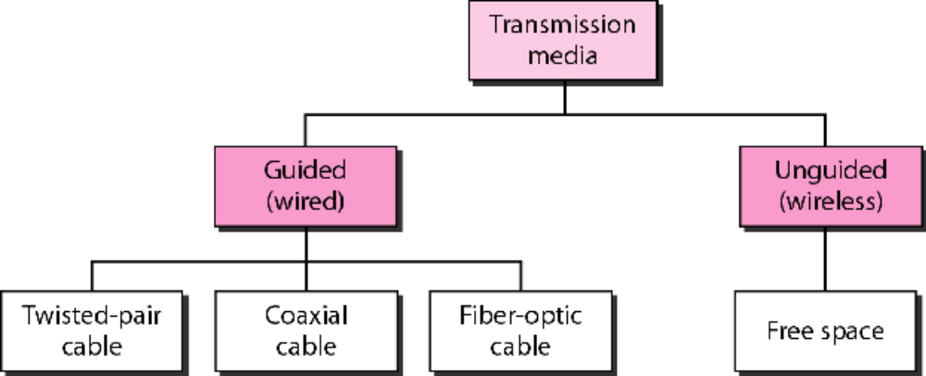
Fig 1.18 Transmission Media

1.8.1 Guided Media
Guided media, which are those that provide a conduit from one device to another, include
twisted-pair cable, coaxial cable, and fiber-optic cable.

Twisted Pair Cable: A twisted pair consists of two conductors (normally copper), each with its
Own plastic insulation, twisted together. One of the wires is used to carry signals to the receiver,
and the other is used only as a ground reference. The receiver uses the difference between the
two. Twisted-pair cables are used in telephone lines to provide voice and data channels. The
local loop-the line that connects subscribers to the central telephone office commonly consists of
Unshielded twisted-pair cables. The DSL lines that are used by the telephone companies to
Provide high-data-rate connections also use the high-bandwidth capability of unshielded twisted pair cables. Twisted pair Cable is shown below in Fig. 1.19:

Fig 1.19 Twisted Pair Cable

Coaxial Cable: Coaxial cable (or coax) as shown in Fig1.20 carries signals of higher frequency
ranges than those in twisted pair cable, in part because the two media are constructed quite
differently. Instead of having two wires, coax has a central core conductor of solid or stranded
wire (usually copper) enclosed in an insulating sheath, which is, in turn, encased in an outer
conductor of metal foil, braid, or a combination of the two. The outer metallic wrapping serves
both as a shield against noise and as the second conductor, which completes the circuit. This
outer conductor is also enclosed in an insulating sheath, and the whole cable is protected by a
plastic cover as shown in figure below:
Coaxial cable was widely used in analog telephone networks where a single coaxial network
could carry 10,000 voice signals. Later it was used in digital telephone networks where a single
coaxial cable could carry digital data up to 600 Mbps. However, coaxial cable in telephone
networks has largely been replaced today with fiber-optic cable

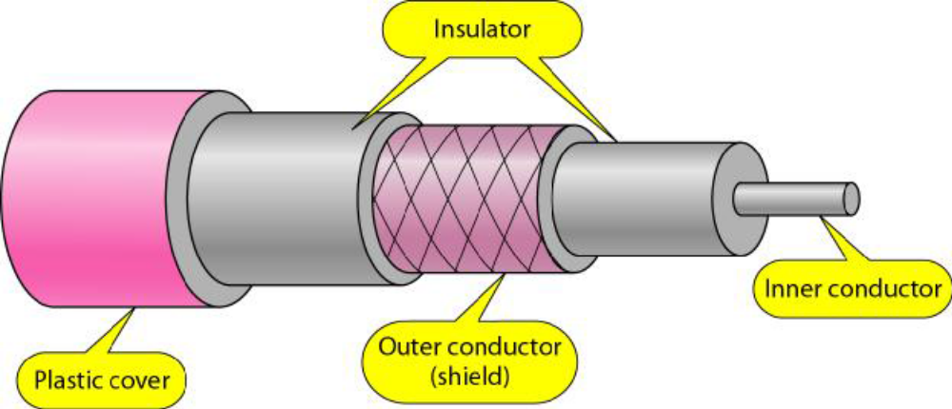
Fig 1.20 Coaxial Cable

Fiber Optic Cable: A fiber-optic cable is made of glass or plastic and transmits signals in the
form of light. To understand optical fiber, we first need to explore several aspects of the nature
of light. Light travels in a straight line as long as it is moving through a single uniform substance.
If a ray of light traveling through one substance suddenly enters another substance (of a different
density), the ray changes direction as shown in Fig.1.21
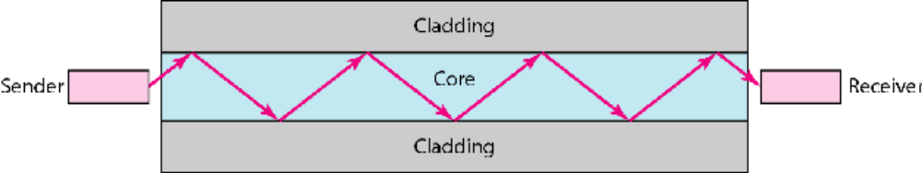
Fig 1.21 Fiber Optic Cable
Fiber-optic cable is often found in backbone networks because its wide bandwidth is costeffective.
Today, with wavelength-division multiplexing (WDM), we can transfer data at a rate
of 1600 Gbps.

1.8.2 Unguided Media
Unguided media transport electromagnetic waves without using a physical conductor. This type
of communication is often referred to as wireless communication. Signals are normally broadcast
through free space and thus are available to anyone who has a device capable of receiving them.
Unguided signals can travel from the source to destination in several ways: ground propagation,
sky propagation, and line-of-sight propagation. Wireless transmission is of three types as shown
below in Fig 1.22:

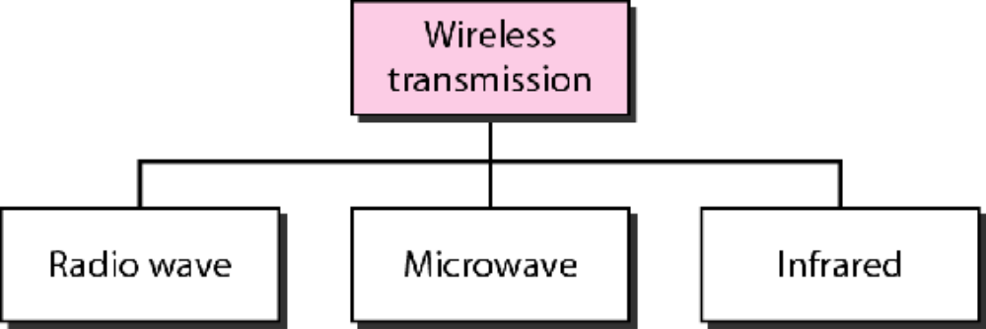

Fig 1.22 Wireless Transmission

Radio Waves: Although there is no clear-cut demarcation between radio waves and microwaves,
electromagnetic waves ranging in frequencies between 3 kHz and 1 GHz are normally called
radio waves; waves ranging in frequencies between 1 and 300 GHz are called microwaves.
However, the behavior of the waves, rather than the frequencies, is a better criterion for
classification. Radio waves use omni-directional antennas that send out signals in all directions.
The omni-directional characteristics of radio waves make them useful for multicasting, in which
there is one sender but many receivers. AM and FM radio,television, cordless phones, and
paging are examples of multicasting.
Microwaves: Electromagnetic waves having frequencies between 1 and 300 GHz are called
microwaves. Microwaves are unidirectional. When an antenna transmits microwave waves, they
can be narrowly focused. This means that the sending and receiving antennas need to be aligned.
The unidirectional property has an obvious advantage. A pair of antennas can be aligned without
interfering with another pair of aligned antennas. Microwaves, due to their unidirectional
properties, are very useful when unicast (one-to-one) communication is needed between the
sender and the receiver. They are used in cellular phones, satellites and wireless LANs.
Infrared: Infrared waves, with frequencies from 300 GHz to 400 THz (wavelengths from 1 mm
to 770 nm), can be used for short-range communication. Infrared waves, having high
frequencies, cannot penetrate walls. This advantageous characteristic prevents interference
between one system and another; a short-range communication system in one room cannot be
affected by another system in the next room. When we use our infrared remote control, we do
not interfere with the use of the remote by our neighbors. However, this same characteristic
makes infrared signals useless for long-range communication. In addition, we cannot use infrared
waves outside a building because the sun's rays contain infrared waves that can interfere with the
communication. The infrared band, almost 400 THz, has an excellent potential for data
transmission. Such a wide bandwidth can be used to transmit digital data with a very high data
rate. The Infrared Data Association (IrDA), an association for sponsoring the use of infrared
waves, has established standards for using these signals for communication between devices
such as keyboards, mice, PCs, and printers. For example, some manufacturers provide a special
port called the IrDA port that allows a wireless keyboard to communicate with a PC. The
standard originally defined a data rate of 75 kbps for a distance up to 8 m. The recent standard
defines a data rate of 4 Mbps.

